**Portfolio**

**Student Version**

**ICTWEB452**

**Create a markup language document**

First published 2021

RTO Works

[www.rtoworks.com.au](http://www.rtoworks.com.au)

[hello@rtoworks.com.au](mailto:hello@rtoworks.com.au)

**0452 157 557**

© 2021 RTO Works

This resource is copyright. Apart from any fair dealing for the purposes of private study, research, criticism or review as permitted under the *Copyright Act* 1968, no part may be reproduced by any process without written permission as expressed in the RTO Works License Agreement.

The information contained in this resource is, to the best of the project team’s and publisher’s knowledge true and correct. Every effort has been made to ensure its accuracy, but the project team and publisher do not accept responsibility for any loss, injury or damage arising from such information.

While every effort has been made to achieve strict accuracy in this resource, the publisher would welcome notification of any errors and any suggestions for improvement. Readers are invited to write to us at [hello@rtoworks.com.au](mailto:hello@rtoworks.com.au).

IT Works is a series of training and assessment resources developed for qualifications within the Information and Communications Technology Training Package.

CONTENTS

Section 1: Prepare to develop web pages 5

Section 2: Create web pages 7

Section 3: Validate web pages 8

|  |  |
| --- | --- |
| Student name: | Ivy/Liu Jiayuan |
| Assessor: | Chuan |
| Date: | 22/3/2023 |

You are a website designer. This assessment is to design a website showcasing your website design skills. Requirements:

* + Page 1: Home Page. Introduce yourself
  + Page 2: Design Portfolio. Pictures gallery can be added here to list sample design. You may copy sample designs from internet. Capture screenshots of these designs and save as picture (image) files. At least 10 designs (pictures) should be included in this page.
  + Page 3: Design Method. Storyboard or wireframe can serve as communication tool to convey design ideas. Additionally, you may draw a flow chart to illustrate your design process.

Design your website in CSS layout.

Minimum of 8 comments must be added to your CSS.

Required webpage components

• images

• graphics (picture)

• animation or video

• links.

• Footer

• Personal logo (with image and text)

• Consistent design style using external style sheet. Design CSS page layout and navigation bar.

• Picture gallery

• CSS fonts

* Table (4x4)

Section 1: Prepare to develop web pages

|  |  |
| --- | --- |
| Uses and audience  *List the uses there will be for your website (web pages). List at least 3 functions and 3 functions of your website.*  *Describe the audience for your website. List at least 3 types of audience.* | Purpose: Use this page to introduce yourself and showcase your website design process to visitors.  Function:  1. Display images and text  2. Interactive content such as videos and links  3. Different CSS fonts and colors  Audience:  1.A salesman who promotes his product  2.small business owners  3.individual customer |
| Markup language  *Document the markup language you will use. Explain your rationale for choosing this markup language for your webpage and audience.*  *(For instance, why choose html, do you have other choices? List 3 reasons to support your choice)* | 1. Standardization and Compatibility: HTML is a standardized markup language used to create and design the structure and content of web pages. It is supported by all mainstream browsers, ensuring compatibility and consistency of web pages on various devices and platforms. 2. Easy to learn: The syntax of HTML is very simple, easy to learn and use. It provides basic tags for building various components of a webpage, such as paragraphs, links, images, etc. 3. Scalability and flexibility: HTML can be combined with many other technologies, such as CSS (for style design) and JavaScript (for interactive functionality), to create feature rich and visually appealing web pages. Meanwhile, HTML also supports the use of various extended markup languages and frameworks, such as XML, SVG, React, etc. |
| Documentation  *List the documentation that you will need to develop the web pages. (list at least 3 documentations and their values in 50 words)*  *Make sure you refer to the simulation pack to assist with including your answer.* | 1.Simulation pack:Provides the main content and component requirements of the webpage  2.Student guide:Introduce some knowledge of web design and provide some web code and software. It provides relevant issues to consider in the web design process.  3.W3school: Provide code for web components |
| Document structure  *Include an outline of the structure of your web pages, as well as the web pages components you will use.*  *Use a diagrammatic structure to show the layout where possible.* | Web document structure:  <!DOCTYPE html>  <html>  <head>  <title>Page Title</title>  </head>  <body>  <h1>This is a Heading</h1>  <p>This is a paragraph.</p>  </body>  </html>  Web pages components:  images  graphics (picture)  videos  links.  Footer  Personal logo (with image and text)  CSS layout and navigation bar using external style sheet  Picture gallery  CSS fonts  Table (4x4)  See appendix 2 for wireframe:At the end of the document.  The first one is the header of the webpage, followed by the text content of the webpage. Below the text content is an image, followed by a table, and then the footer of the webpage. There are two more links, one to the image library and the other to the storyboard |
| Accessibility  *Explain how you will ensure that your website meets accessibility requirements* | (1) Add navigation bar for customers to easily click and jump to  (2) Add video explanations to help visitors understand online content.  (3) Add a flowchart to inform visitors of the website design process |

Section 2: Create web pages

|  |  |  |
| --- | --- | --- |
| Text editor  *Identify the text editor you will use here.* | 1. Notepad++(2)Brackets (3)Visual Studio Code   Final: Visual Studio Code  List at least 3 reasons to choose the above editor   1. Cross platform support: VS Code can run on Windows, Mac, and Linux, adapting to different operating systems. 2. Built in Debugger: VS Code has a built-in debugger that can help developers quickly debug code. 3. Powerful search function: Supports global search and replacement functions, allowing for quick discovery of desired content.   3 Advantages:   1. Intelligent auto completion: It has intelligent auto completion function, which can help programmers input code faster. 2. Rich plugin system: It supports various plugins that can be customized according to needs, including syntax highlighting, intelligent code completion, custom hotkeys, bracket matching, code snippets, code comparison Diff, Git, and other features. 3. Support for multiple programming languages: suitable for development in multiple programming languages, including web development, backend development, mobile application development, etc.   3 Disadvantages:   1. Resource occupancy: Although VS Code has a relatively small resource occupancy, in some cases, such as opening a large number of files or running a large number of plugins, it may lead to excessive system resource occupancy and affect performance. 2. Learning curve: VS Code has a large number of features and plugins, which may take some time for beginners to become familiar with. Additionally, due to its highly configurable nature, it may be too complex for some users. 3. Community support: Although VS Code has a large user community and a rich plugin ecosystem, other editors may be more popular in certain specific fields or languages, which means community support and resources may not be as abundant as other editors. | |
| Using the text editor, create your web pages including applying styles  *Take screenshots of the code you generate and attach them to your Portfolio.*  *List the title of the screenshots here.* | Page 1: The top is the title, the bottom is the navigation bar, below is my introduction and my own photo, followed by interests, then my logo, then the target, then two links, then a table, and then the footer  Page 2: First is the title, then the navigation bar, and then ten images  Page 3: First is the title, then the navigation bar, then the storyboard, then the flowchart and video, and finally the footer  See appendix 1 for screenshots:At the end of the document.  Links to Github pages  Page 1:  Page 2:  Page 3:  Links to Github source codes  Page 1:  Page 2:  Page 3: | |
| *Paperclip* Attach: | Screenshots |  |

Section 3: Validate web pages

|  |  |  |
| --- | --- | --- |
| Browser and devices  *You are to test that your web pages work on:*   * *two different types of browsers* * *two different types of devices*   *List the two browsers you tested your web pages on and the two devices.*  *Take screenshots of your work to attach to your portfolio.*  *Note down at least one change you need to make to your web pages.* | Two different types of browsers:Google Chrome,Microsoft Edge  Two different types of devices:Computer,Desktop computer  Change:Web pages need to be prettier  Open websites on your computer using Google Chrome and Edge. Next, use Edge and Google Chrome to open it on the desktop. Observe if the website is running properly  See appendix 4 :At the end of the document | |
| Specifications  *Check that you have covered all of the specifications for the web pages.*  *Provide a brief description here of how you have achieved this.*  *Click [here](https://highrise.digital/blog/web-specification-guide/" \l ":~:text=A%20website%20specification%20is%20a,stakeholders%20or%20points%20of%20contact.) [link2](https://wemakewebsites.com/blog/how-to-write-a-website-specification/) for sample website specifications* | (1) Overview: Introduction to web content  (2) Goal: Self introduction  (3) Function: Describe the functionality of a webpage  (4) Browser and device support: This section introduces the browsers and devices supported by web pages  (5) Content structure: Describe the main structure of each webpage  (6) Continuous support and maintenance: Describe web support and follow-up  See appendix 3 :At the end of the document | |
| Sign off  *Send an email to your assessor explaining how you have met requirements for this task, providing a link to your final web pages and seeking approval.* | Dear Chuan  This is Ivy/Liu Jiayuan, I have completed this web assessment and met requirement because my web page has self-introduction, picture display, storyboard and flow chart, which can achieve the purpose of introducing myself to visitors. My website supports different devices and browsers to open, and through links to achieve webpage jump, but also added videos and pictures to help visitors understand my website content.I want my website to be seen and known by more people who need web design, so that I can help them make beautiful web pages and I will continue to beautify my website and add more interactive functions to improve user experience.This is my final .I know how to use CSS style to beautify my web pages and master.Please approve through my web page. | |
| *Paperclip* Attach: | Screenshots |  |

Appendix 1

Page1:

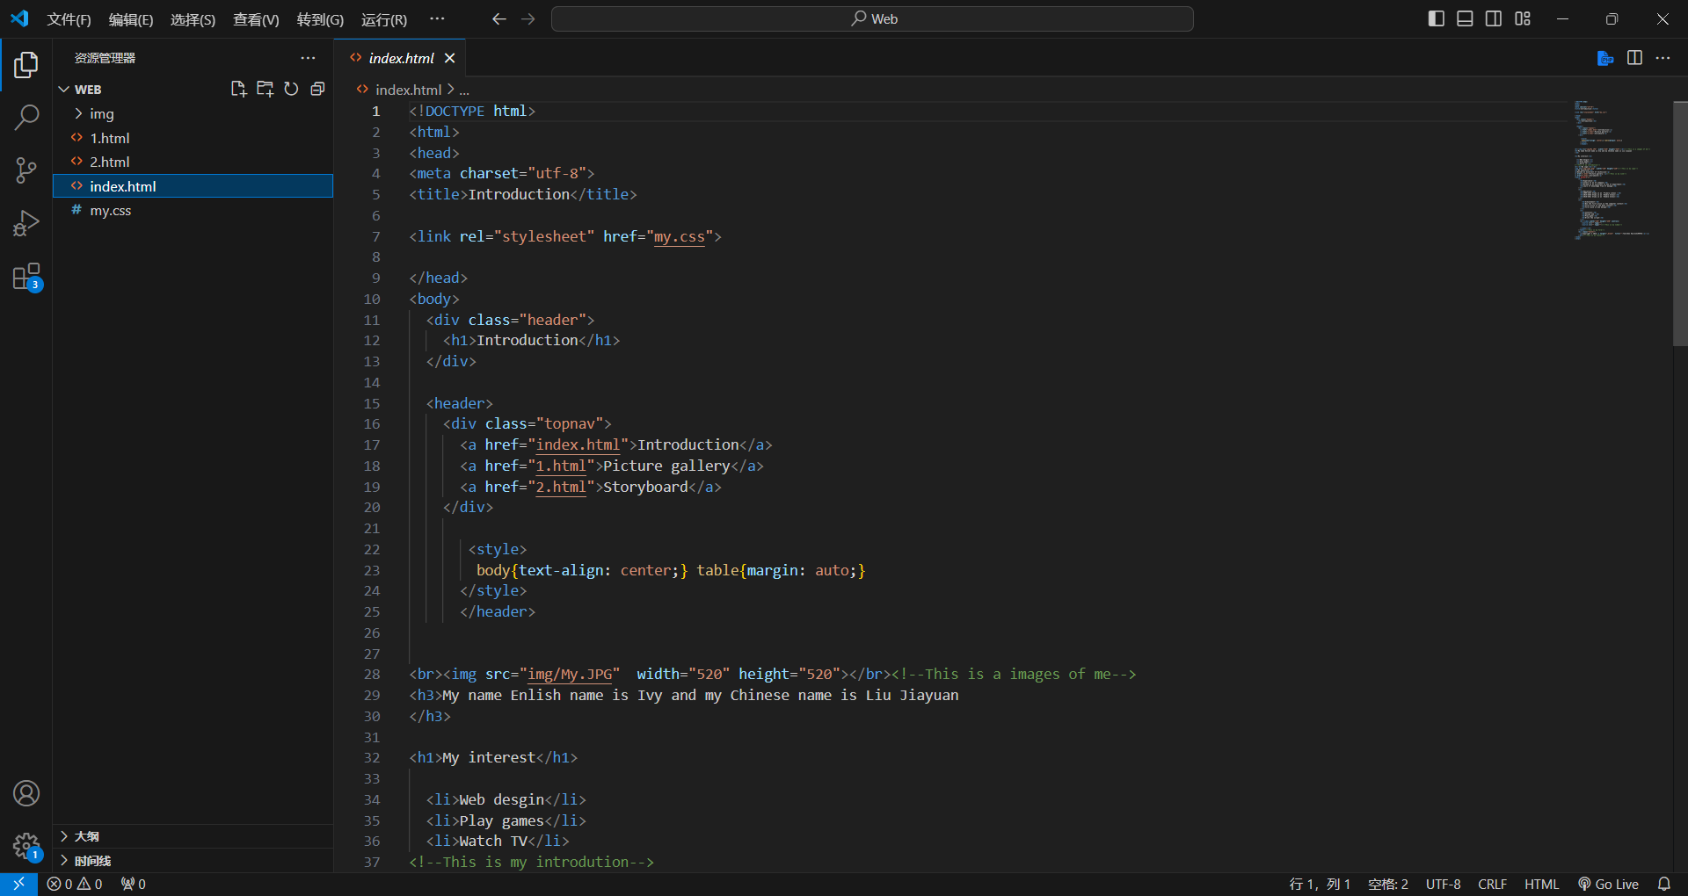

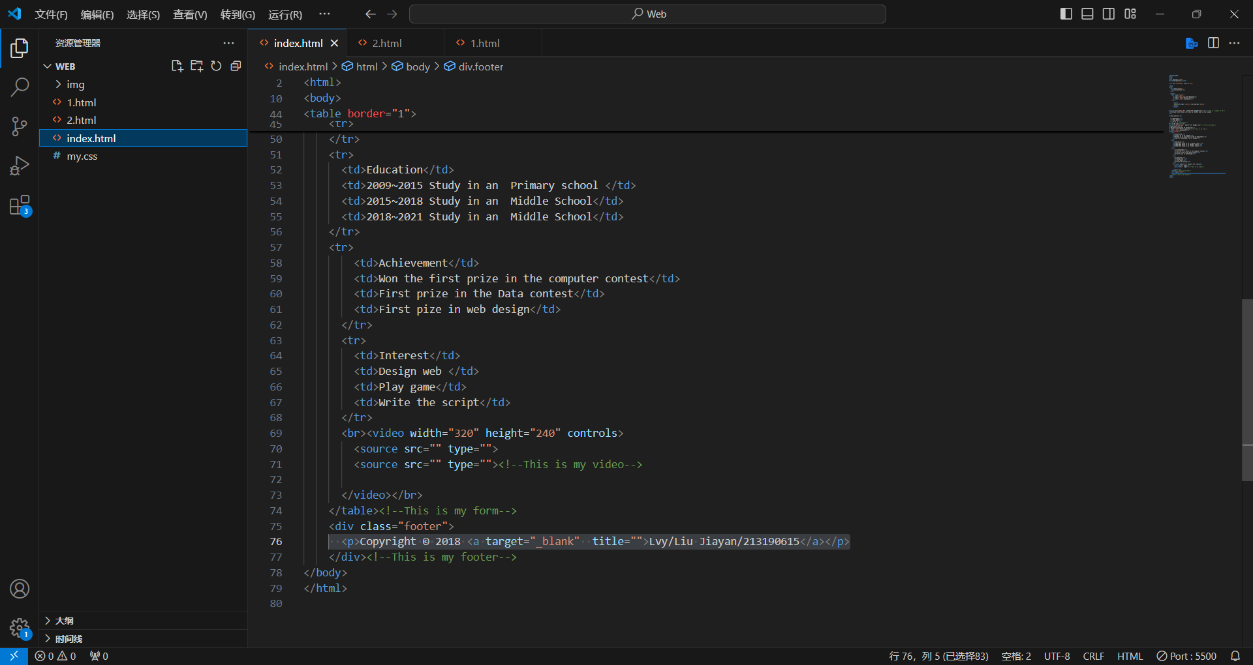

Page2:

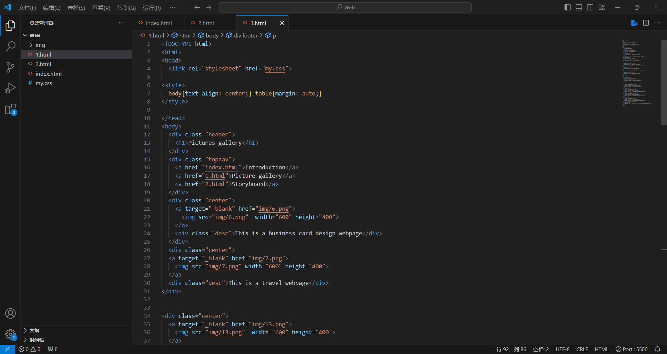

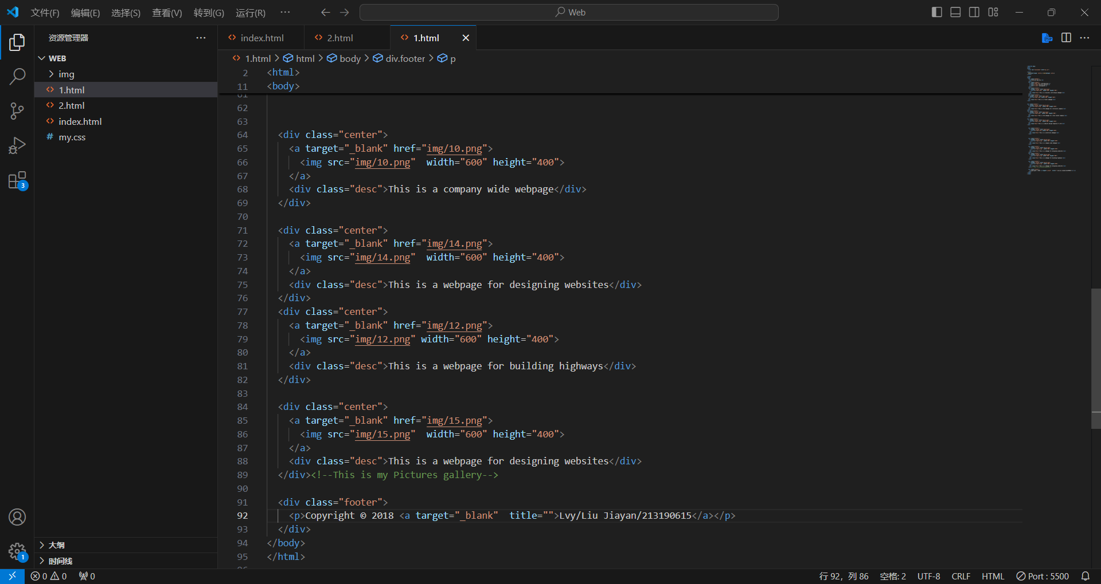

Page3:

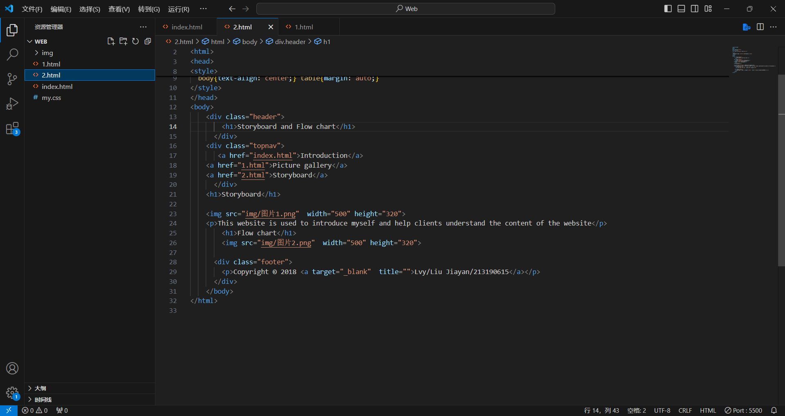

Appendix 2

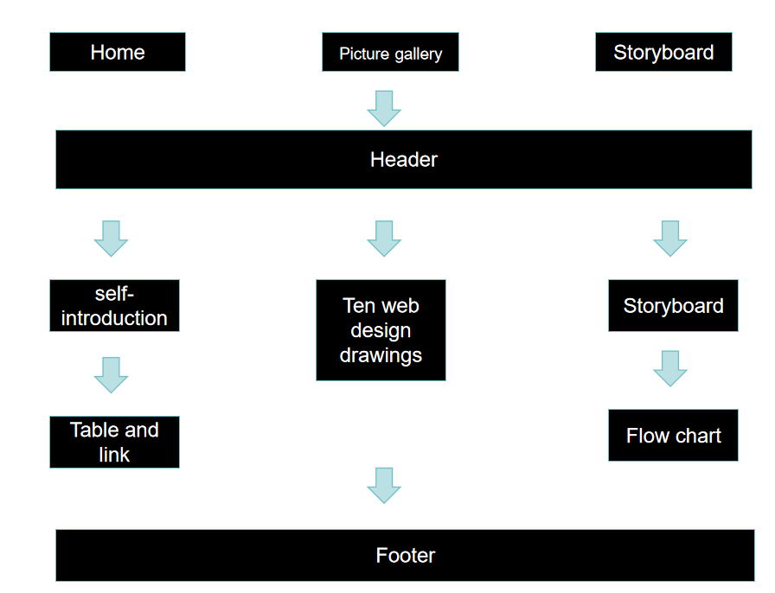

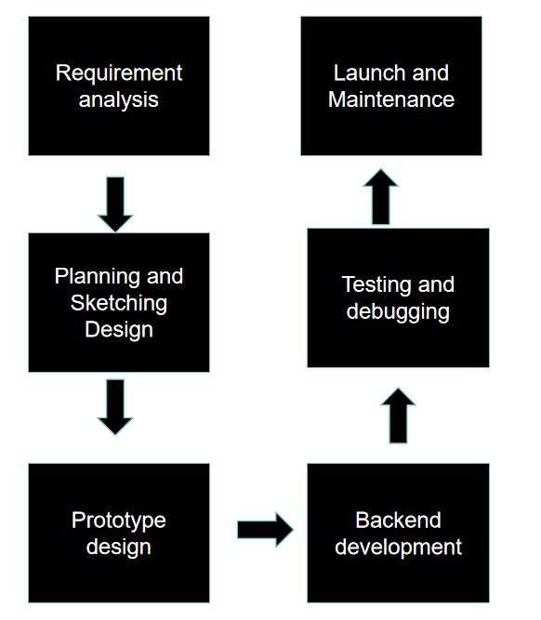

Appendix 3 Website design specifications

(1) Overview: I am a web designer. This webpage is about my self introduction

(2) Goal: I want to use this webpage to introduce myself and promote myself, helping me find clients

(3) Function: I increased accessibility by using HTML and CSS to display images and text, and also added video and navigation bar modules that visitors can interact with

(4) Browser and device support: I can open web pages on multiple browsers and different devices

(5) Content structure:

Page 1: Above is the title, below is the navigation bar, below is my introduction and my own image, then my interests, then interests, then my logo, then goals, then two links, then a table, and then a footer

Page 2: First, the title, then the navigation bar, and then ten images

Page 3: First is the title, then the navigation bar, then the storyboard, then the flowchart and video, and finally the footer

(6) Continuous support and maintenance: Continuously updating one's own webpage on the website, and maintaining the webpage when it cannot be opened

Appendix 4

Computer:Edge and Google Chrome

Edge

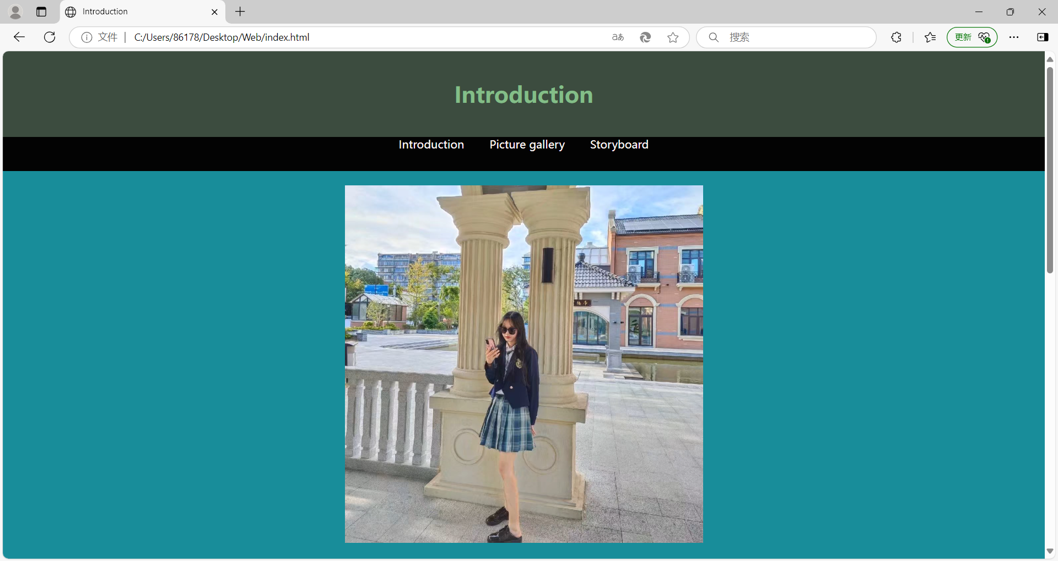

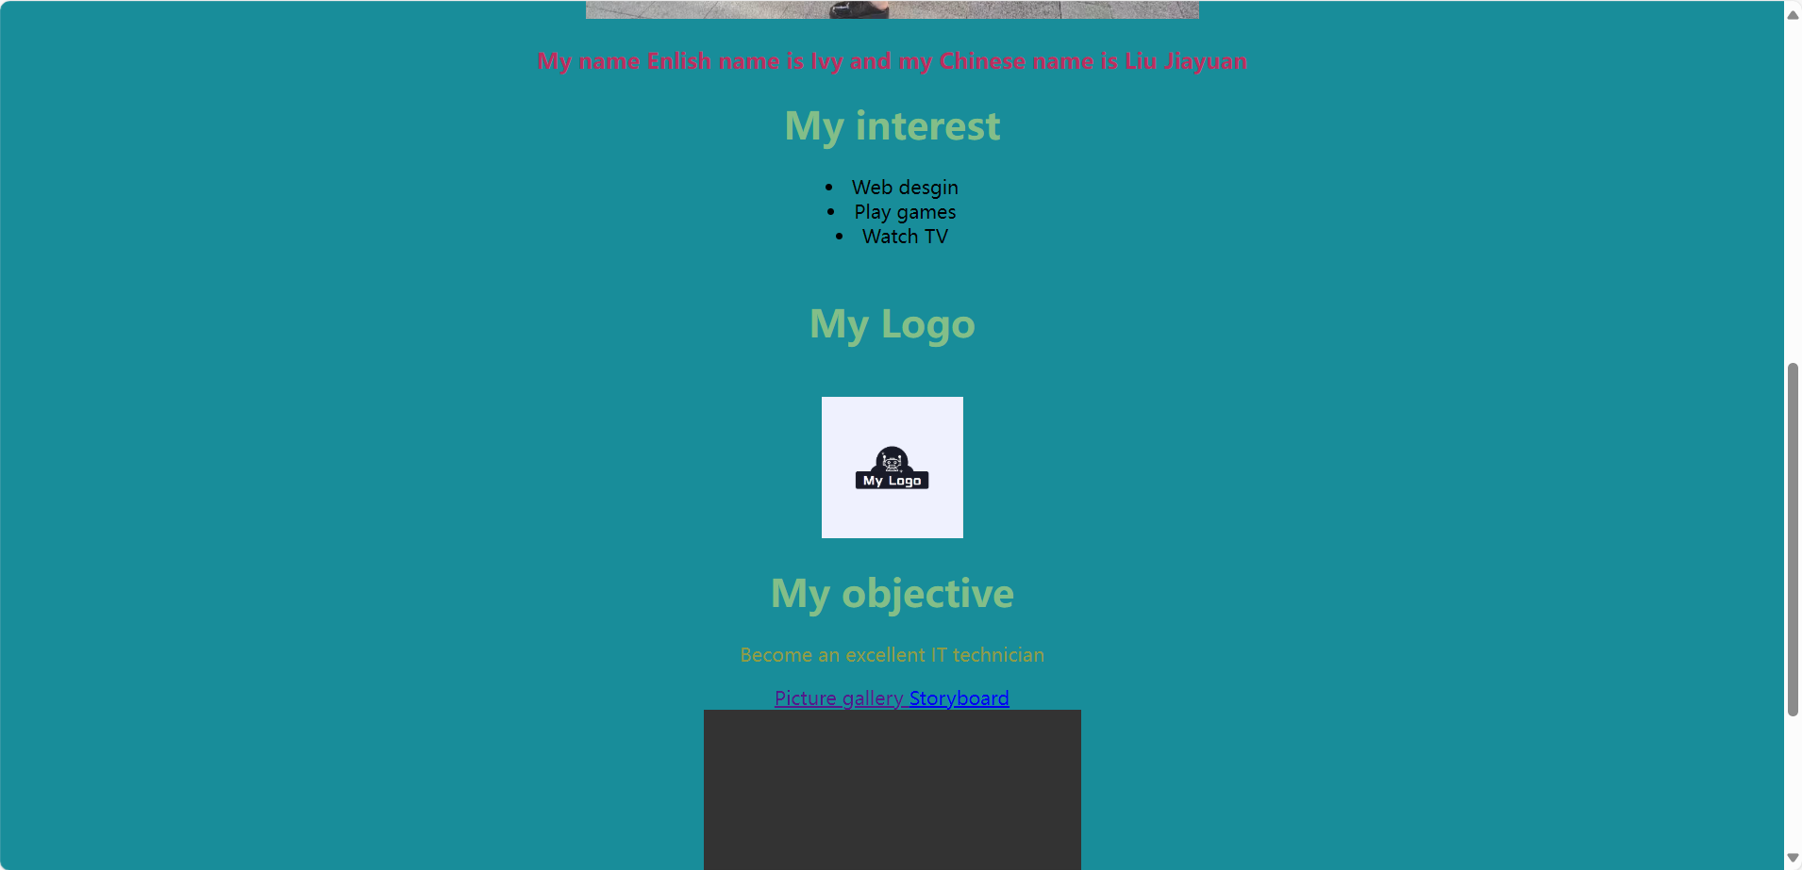

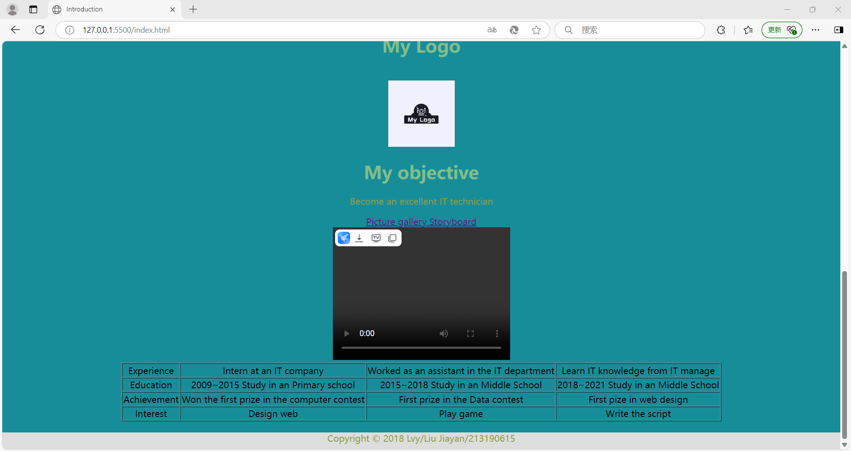

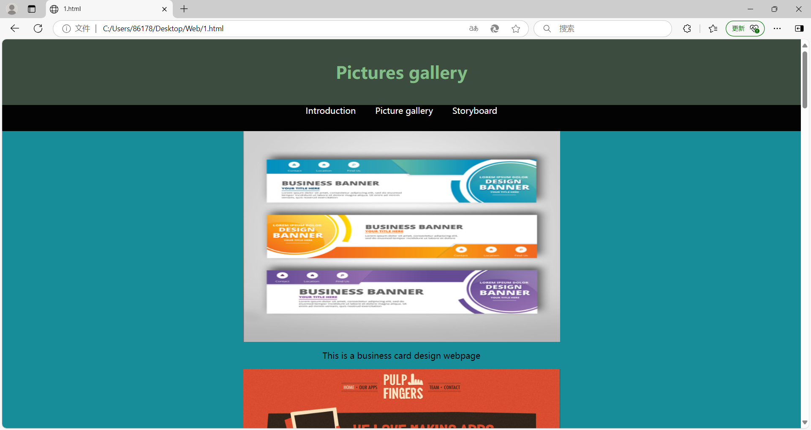

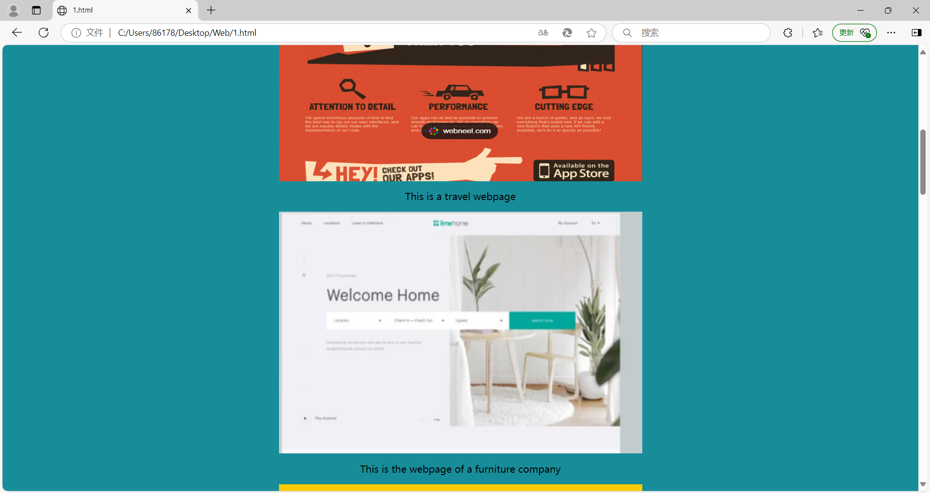

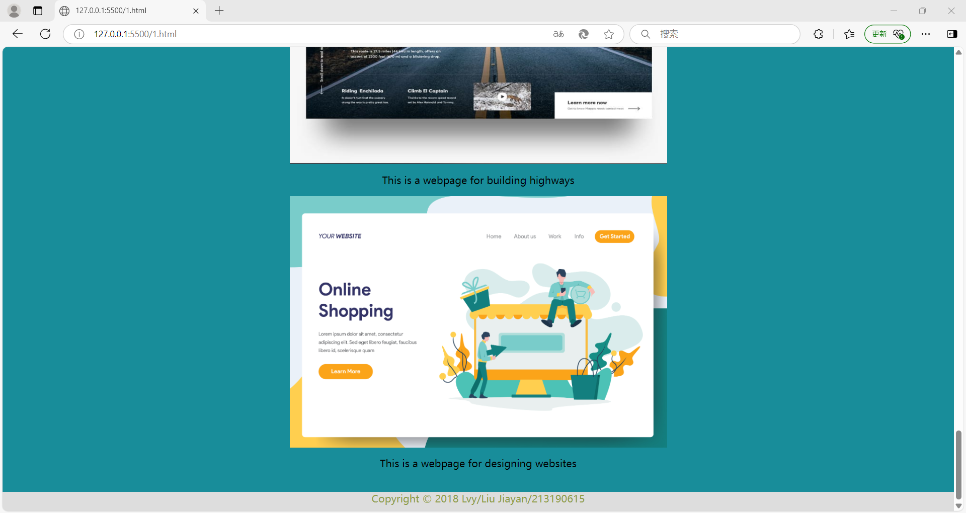

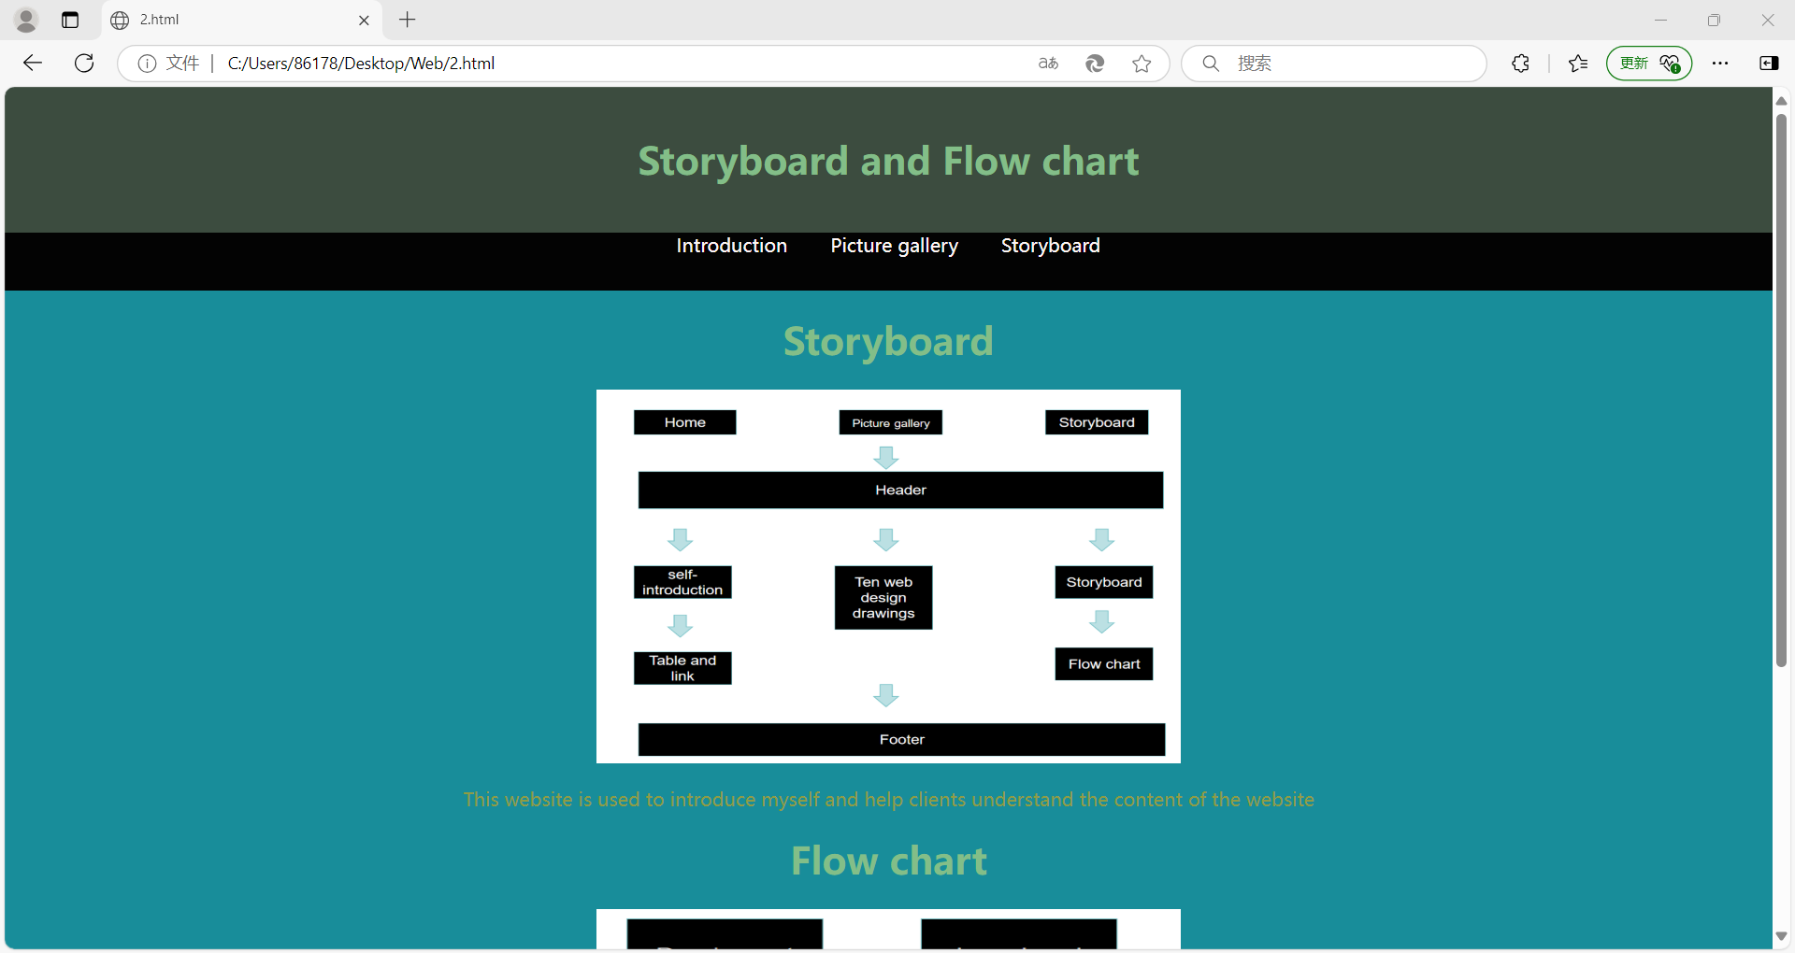

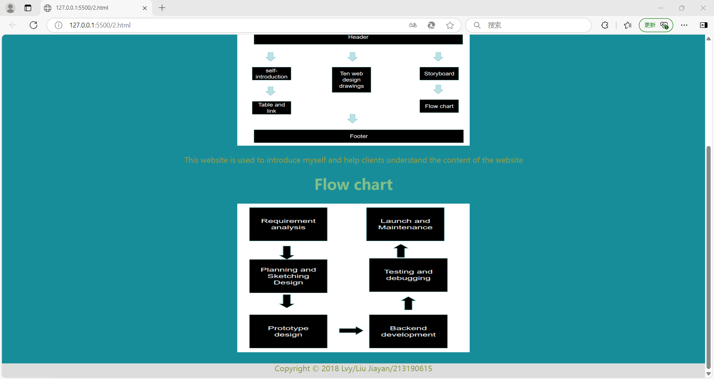

Google Chrome

















Desktop computer















